

Economics

SAC 3.1 UNIT 3 OUTCOME 3

You will have 45 minutes to complete this task plus 5 minutes reading time

Teacher: Mr. Daniel Charles

The total SAC contributes to 30/100 of SAC marks allocated for Unit 3.

Allowed materials for this task include:
- Pens, pencils, rulers, erasers, highlighters

Name ____________________________________________

Note: The grade or score for this task is only part of the internal assessment for this Unit. Your total School-assessed Coursework score may change as a result of statistical moderation by VCAA.

Grade/Score: ______ Satisfactory Completion? S/N: ______
(Provisional)
VCE ECONOMICS
SCHOOL-ASSESSED COURSEWORK
Performance Descriptors
Unit 3  Outcome 3  Explain the factors that may influence Australia’s international transactions and evaluate how international transactions and trade liberalisation may influence the current account balance, the Australian Government’s domestic macroeconomic goals and living standards in Australia. | DESCRIPTOR: typical performance in each range
 | Very low | Low | Medium | High | Very high
 | Limited understanding of the factors that influence Australia’s transactions with the rest of the world. | Some understanding of the factors that influence Australia’s transactions with the rest of the world. | Satisfactory understanding of the factors that influence Australia’s transactions with the rest of the world. | Generally thorough understanding of the factors that influence Australia’s transactions with the rest of the world. | Sophisticated understanding  of the factors that influence Australia’s transactions with  the rest of the world.
 | Discussion demonstrates a limited understanding of the effects of international transactions and trade liberalisation on the current account balance, domestic macroeconomic goals and  living standards. | Some evaluation of the effects of international transactions and trade liberalisation on the current account balance, domestic macroeconomic goals and living standards. | Satisfactory evaluation of  the effects of international transactions and trade liberalisation on the current account balance, domestic macroeconomic goals and  living standards. | Well developed evaluation of  the effects of international transactions and trade liberalisation on the current account balance, domestic macroeconomic goals and  living standards. | Sophisticated evaluation of  the effects of international transactions and trade liberalisation on the current account balance, domestic macroeconomic goals and  living standards.
 | Limited use and application of economics terms, concepts, theories and data in the analysis and discussion. Little use of relevant data and evidence to support the explanation and discussion. | Some accurate application of knowledge and use of specialist economic terms, concepts and theories. Some reference to relevant data and evidence but not always applied appropriately. | Satisfactory selection, use and application of economics terms, concepts, theories, data and evidence to support the explanation and discussion. | Accurate definition, use and application of economics terms, concepts and theories. Sound use of relevant data and evidence to support the explanation and discussion. | Confident and accurate definition, use and application of economics terms, concepts and theories. Sophisticated use of relevant data and evidence to support the explanation and discussion.
 | Limited analysis and little understandings of international economic relationships. Reasoning and interpretation lacks clarity. Little evidence of an ability to synthesis arguments or draw appropriate conclusions. | Some understanding of international economic relationships with some relevant conclusions. Some use of relevant evidence, synthesis of arguments and logical economic reasoning. | Generally satisfactory analysis  of international economic relationships, issues and problems is demonstrated. Adequate ability to synthesis arguments and draw conclusions. | Generally thorough analysis  of international economic relationships, issues and problems is demonstrated. Economic reasoning and interpretation skills and an ability to synthesise arguments and draw conclusions are mostly well developed. | Comprehensive and logical analysis of international economic relationships, issues and problems is demonstrated. Sophisticated skills of economic reasoning and interpretation and an ability to synthesise arguments and draw conclusions are evident.

Section A –Short Answer Questions
Question 1
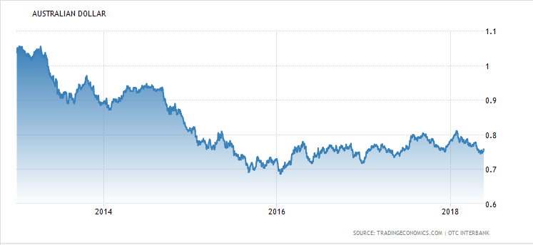
- Describe the trend in the exchange rate since 2016.
2 marks
________________________________________________________________________________________________________________________________________________________________________________________________________________________________________________________________________________________________________________________________________

- Identify and explain one possible cause for the trend in the exchange rate since 2016
2 marks
____________________________________________________________________________________________________________________________________________________________________________________________________________________________________________________________________________________________________________________________________________________________________________________________________________________________________________________________________________________________________________

- Explain the affect that the trend in the value of the $AUD since 2016 would have on one domestic macroeconomic goal
4 marks
________________________________________________________________________________________________________________________________________________________________________________________________________________________________________________________________________________________________________________________________________________________________________________________________________________________________________________________________________________________________________________________________________________________________________________________________________________________________________________________________________________________________________________________________________________________________________________________________________________________________________________________________________________________________________________________________________________________________________________________________________________________________________________________________________________________________________________________________________________________________________________________________________________________________________________________________________________________________________________________________________________________________

Question 2
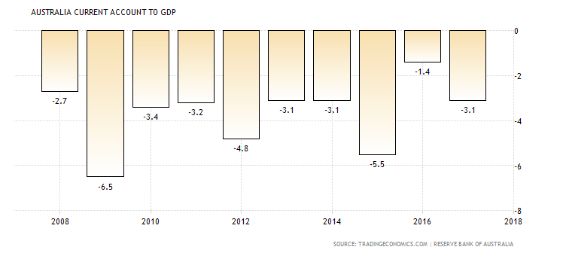

- Referring to the table above, explain what is meant by a current account deficit
2 marks
____________________________________________________________________________________________________________________________________________________________________________________________________________________________________________________________________________________________________________________________________________________________________________________________________________________________________________________________________________________________________________

- Australia has run a current account deficit for many years now, including 2017. Outline one structural cause and one possible cyclical cause for why this is the case.
4 marks

Structural cause
________________________________________________________________________________________________________________________________________________________________________________________________________________________________________________________________________________________________________________________________________________________________________________________________________________________________________________________________________________________________________________________________________________________________________________________________________________________________________________________________________________

Possible cyclical cause
________________________________________________________________________________________________________________________________________________________________________________________________________________________________________________________________________________________________________________________________________
________________________________________________________________________________________________________________________________________________________________________________________________________________________________________________________________________________________________________________________________________

Question 3
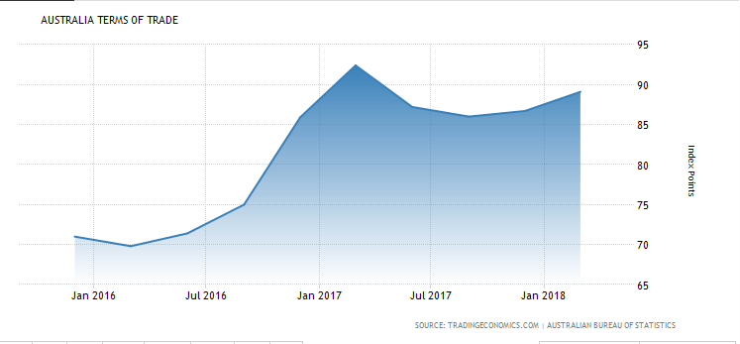
- Identify and explain one possible cause of the trend in Australia’s terms of trade over the last two years.
2 marks
____________________________________________________________________________________________________________________________________________________________________________________________________________________________________________________________________________________________________________________________________________________________________________________________________________________________________________________________________________________________________________

- Explain how the trend in the terms of trade over the last two years would impact the following:
4 marks

The value of the $AUD
________________________________________________________________________________________________________________________________________________________________________________________________________________________________________________________________________________________________________________________________________
Economic growth
____________________________________________________________________________________________________________________________________________________________________________________________________________________________________________________________________________________________________________________________________________________________________________________________________________________________________________________________________________________________________________

Question 4
- Explain the impact that trade liberalisation could have on the following:
6 marks
- Structural unemployment
____________________________________________________________________________________________________________________________________________________________________________________________________________________________________________________________________________________________________________________________________________________________________________________________________________________________________________________________________________________________________________

- Cyclical unemployment
____________________________________________________________________________________________________________________________________________________________________________________________________________________________________________________________________________________________________________________________________________________________________________________________________________________________________________________________________________________________________________

- The inflation rate
____________________________________________________________________________________________________________________________________________________________________________________________________________________________________________________________________________________________________________________________________________________________________________________________________________________________________________________________________________________________________________

Question 5

- Analyse the relationship between the exchange rate and the current account balance.
4 marks
____________________________________________________________________________________________________________________________________________________________________________________________________________________________________________________________________________________________________________________________________________________________________________________________________________________________________________________________________________________________________________________________________________________________________________________________________________________________________________________________________________________________________________________________________________________________________________________________________________________________________________________________________________________________________________________________________________________________________________________________________________________________________________________________________________________________________________________________________________________________________________________________________________________________________________________________________________________________________________________________________________________________________________________________________________________________________________________________________________________________________________________________________

EXTRA WRITING SPACE
________________________________________________________________________________________________________________________________________________________________________________________________________________________________________________________________________________________________________________________________________________________________________________________________________________________________________________________________________________________________________________________________________________________________________________________________________________________________________________________________________________________________________________________________________________________________________________________________________________________________________________________________________________________________________________________________________________________________________________________________________________________________________________________________________________________________________________________________________________________________________________________________________________________________________________________________________________________________________________________________________________________________________________________________________________________________________________________________________________________________________________________________________________________________________________________________________________________________________________________________________________________________________________________________________________________________________________________________________________________________________________________________________________________________________________________________________________________________________________________________________________________________________________________________________________________________________________________________________________________________________________________________________________________________________________________________________________________________________________________________________________________________________________________________________________________________________________________________________________________________________________________________________________________________________________________________________________________________________________________________________________________________________________________________________________________________________________________________________________________________________________________________________________________________________________________________________________________________________________________________________________________________________________________________________________________________________________________________________________________________________________________________________________________________________________________________________________________________________________________________________________________________________________________________________________________________________________________________________________________________________________________________________________________________________________________________________________________________________________________________________________________________________________________________________________________________________________________________________________________________________________________________________________________________________________________________________________________________________________________________________________________________________________________________________________________________________________________________________________________________________________________________________________________________________________________________________________________________________________________________________________________________________________________________________________________________________

